**Program Manual**

计算机科学与技术（全英创新班）

**Content**

1 Login 1

2 Menu-Administrator 2

3 Menu-Teacher 19

4 Menu-Student 21

5 Query 22

6 Modify Password 27

7 Appendix 27

# 1 Login

Run the program “Experiment2.exe” shown in Figure 1.

1719133468504

Figure 1

The login window will be shown as Figure 2.

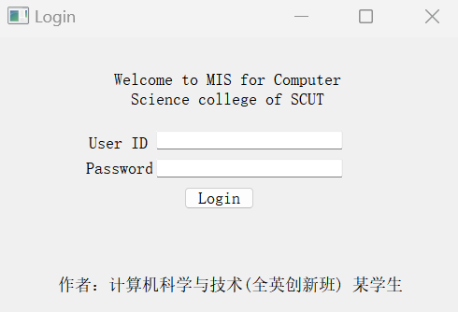

Figure 2

Enter the correct User ID and Password and click “Login” button. User’s occupation will be determined after successful login, including “admin”, “teacher” and “student”. The program initializes some sample accounts, as shown in **Appendix 7.5**.

If the input of User ID is not a decimal number, an error information will be displayed as as Figure 3 and 4.

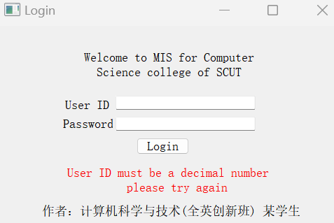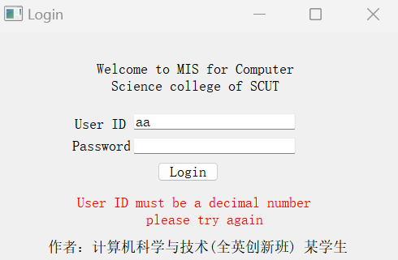

Figure 3 Figure 4

If entering wrong Password or inexistent user ID, an error information will be displayed as Figure 5 and 6.

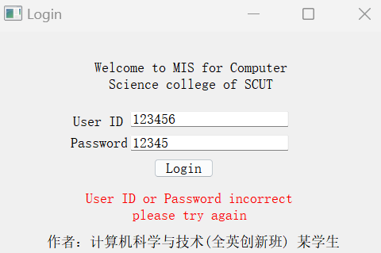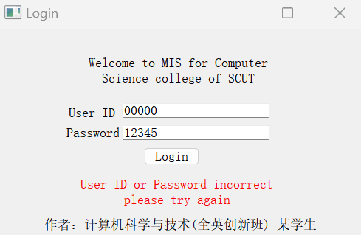

Figure 5 Figure 6

In order to prevent SQL injection attack, if the Password contain the following punctuation{\, /, :, ?, ", ', <, >, |}, an error information will be displayed as Figure 7.

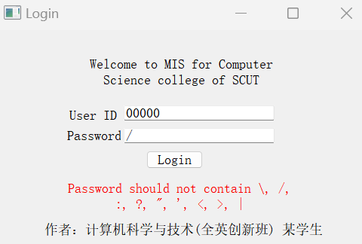

Figure 7

If the user ID and password is correct, click “Login” button and jump to corresponding menu of different occupation. For administrator, please refer to **2 Menu-Admin**; for teacher, please refer to **3 Menu-Teacher**; for student, please refer to **4 Menu-Student**.

# 2 Menu-Admin

Take user ID=00000 as sample account to login. The menu is shown in Figure 8.

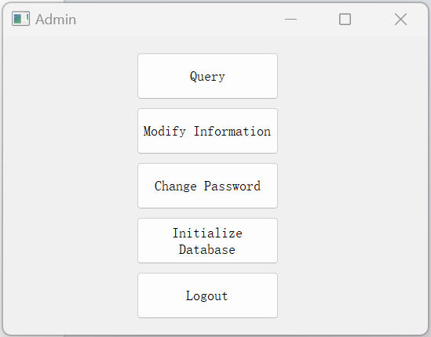

Figure 8

Click the button to achieve corresponding operation.

**2.1 Query**

After clicking “Query” button, jump to the window for different query demand. Please refer to **5 Query** for detailed introduction.

**2.2 Modify Information**

After clicking “Modify Information” button, jump to the window for different modifying demand as shown in Figure 9.

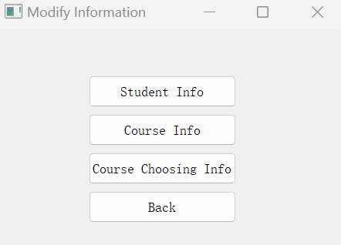

Figure 9

**2.2.1 Student Info**

After clicking “Student Info” button, jump to the window for querying student information as Figure 10.

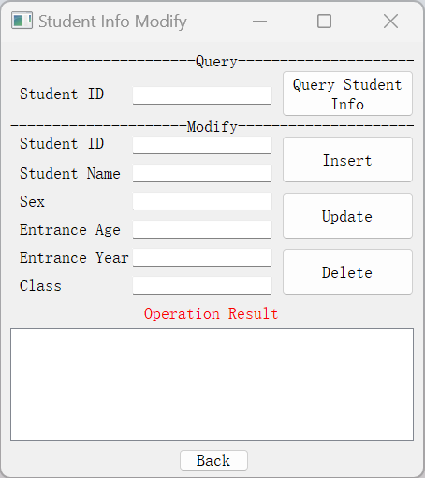

Figure 10

**2.2.1.1 Query Student Info**

If you press the “Query Student Info” button with empty Student ID, information of all the students will be shown as Figure 11, else if the Student ID is not empty, the program will check if Student ID is a 10 digit decimal number, if not, an error prompt will be shown as Figure 12, if yes, the program will query for the information of this student as Figure 13. If there is no matched student, a prompt will be shown as Figure 14.

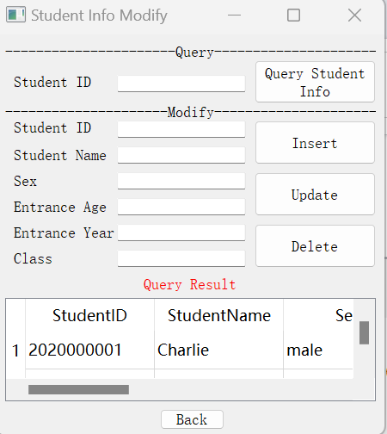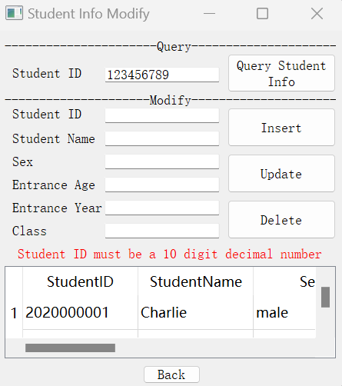

Figure 11 Figure 12

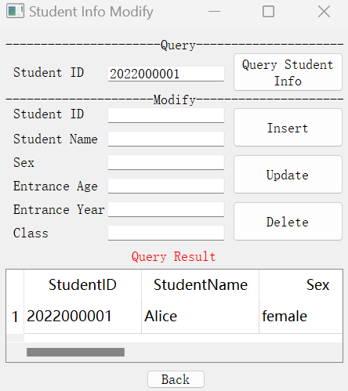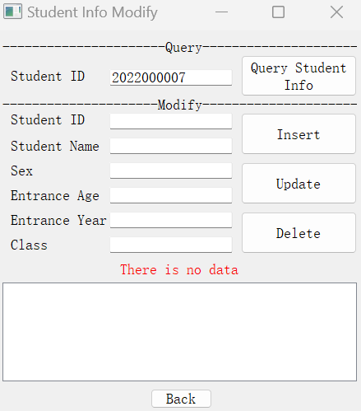

Figure 13 Figure 14

**2.2.1.2 Insert**

Insert a student must input all the attributes correctly, the Student ID must be a 10 digit decimal number, the Student Name must be an English name without spaces, the Sex must be “male” or “Female”, the Entrance Age must be a decimal number in range [10,50], the Entrance Year must be a decimal number, the Class should not be empty, also here has a dealing with SQL injection attack. If the input is invalid, there will be some prompts to tell the user as Figure 15-21. The error format input handling for **2.2.1.3 Update** and **2.2.1.4 Delete** is the same as here. If all the input is valid, then a prompt will tell user that the insertion is successful as Figure 22. Also when insert a student’s information, the account of this student will be created and the password will be “123456”.If the input Student ID has already exist, a prompt will be shown as Figure 23.

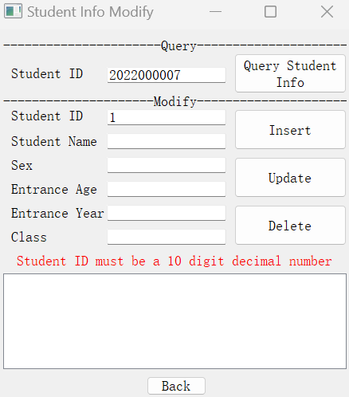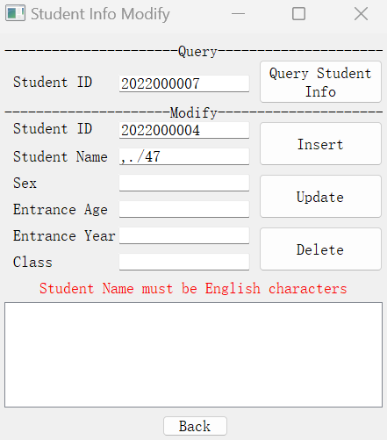

Figure 15 Figure 16

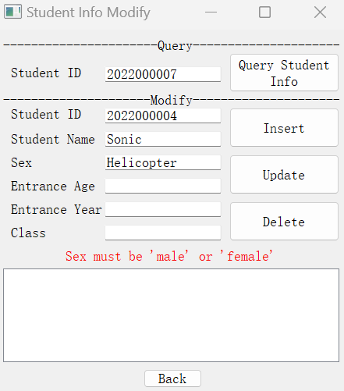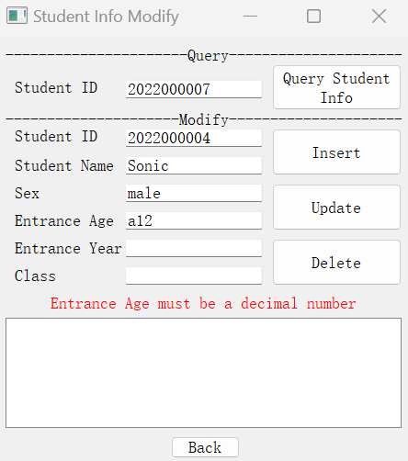

Figure 17 Figure 18

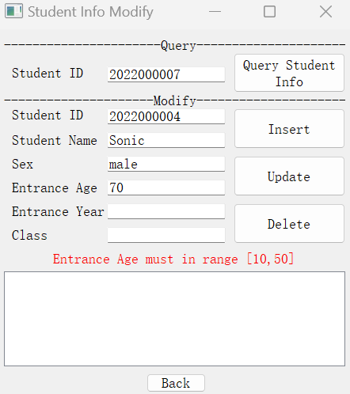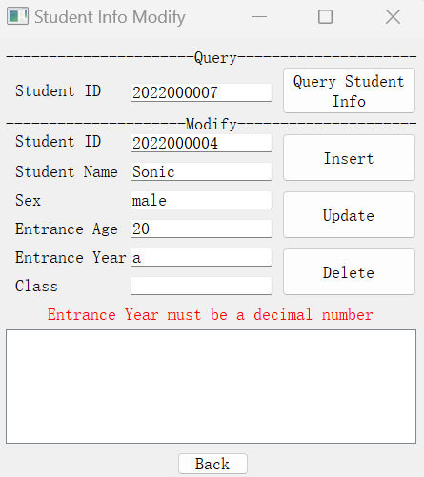

Figure 19 Figure 20

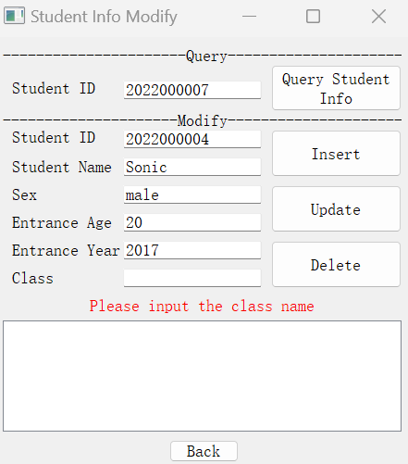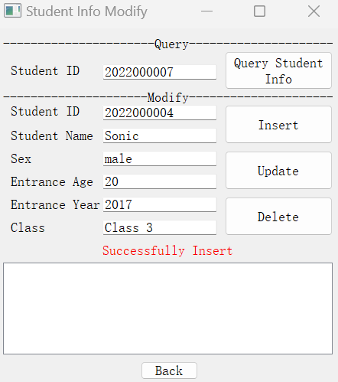

Figure 21 Figure 22

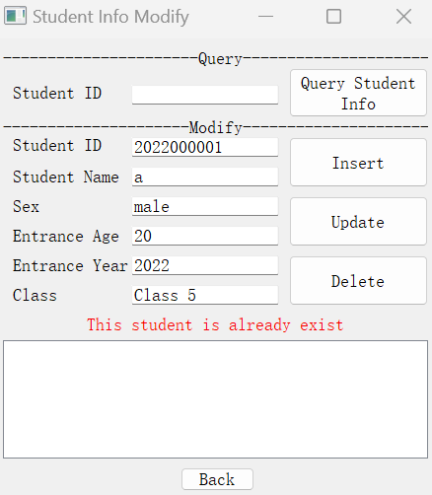

Figure 23

**2.2.1.3 Update**

To update a student’s information, user must input Student ID correctly. If there is no matched student, a prompt will be shown to tell the user as Figure 24. The other attributes can be empty or nonempty. If is empty, then this attribute will not be update, else this attribute will be update if the new one is valid. If all the input is correct, then a prompt will be shown to tell the user that the update is successful as Figure 25, and the update effect is shown in Figure 26 and 27.

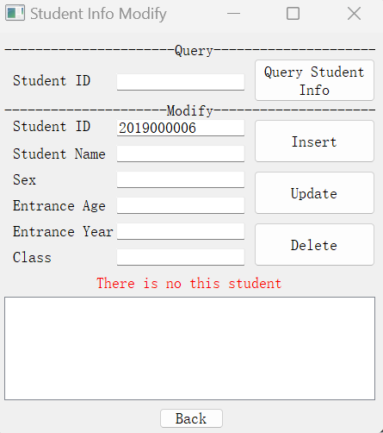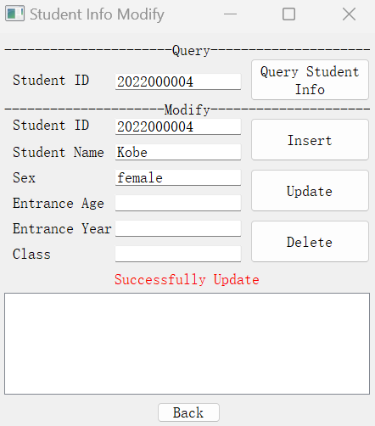

Figure 24 Figure 25

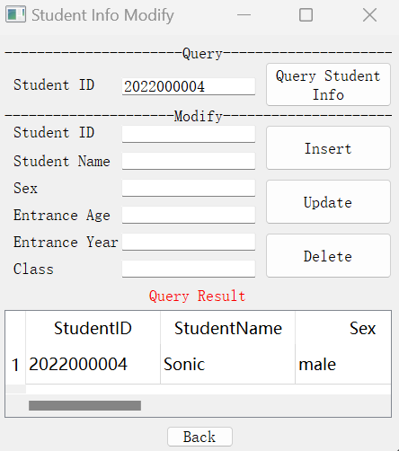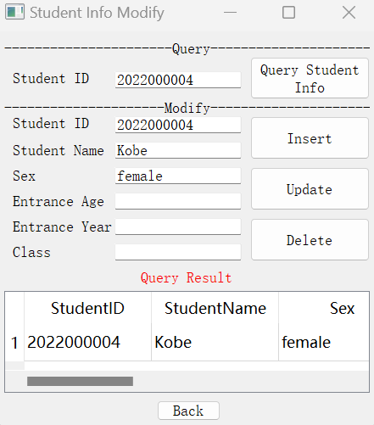

Figure 26 Figure 27

**2.2.1.4 Delete**

To delete a student’s information, user must input Student ID correctly. If there is no matched student, a prompt will be shown to tell the user as **2.2.1.3 Update**. If the Student ID is correct, then a prompt will tell the user that the delete is successful as Figure 28. Also when delete a student’s information, the account of this student will also be delete.

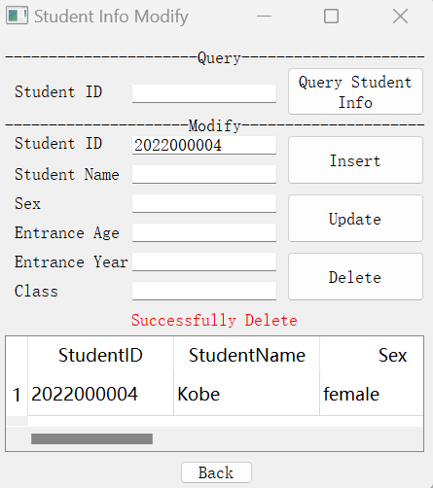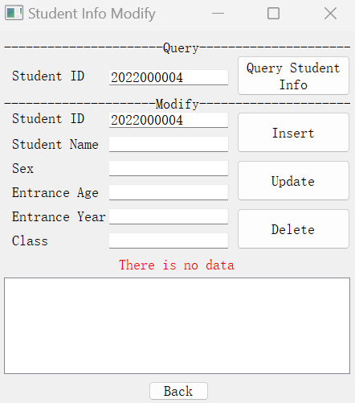

Figure 28 Figure 29

**2.2.2 Course Info**

After clicking “Course Info” button, jump to the window for querying student information shown as Figure 30.

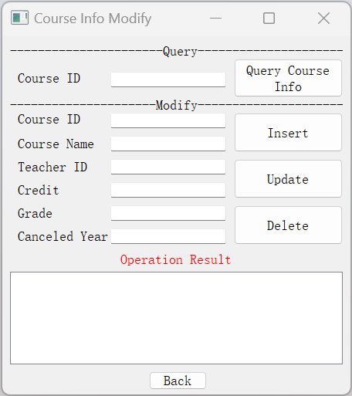

Figure 30

**2.2.2.1 Query Course Info**

If you press the “Query Course Info” button with empty Course ID, information of all the courses will be shown, else if the Course ID is not empty, the program will check if Course ID is a 7 digit decimal number, if not, an error prompt will be shown, if yes, the program will query for the information of this course. If there is no matched course, a prompt will be shown. This is very similar to **2.2.1.1 Query Student Info**, so here will not show figure here.

**2.2.2.2 Insert**

Insert a course must input all the attributes correctly (Canceled Year is optional), the Course ID must be a 7 digit decimal number and not exist in **Table Courses** , the Course Name should not contain any specific punctuation, the Teacher ID must be a 5 digit decimal number and must exist in **Table Teachers**, the Credit must be a float number, the Grade must be a integer number in range [1,5], the Canceled Year must be an integer number or empty. If any attribute is invalid, there will be some prompts to tell the user. If all the attributes are valid, a prompt will be shown to tell the user that the Insert is Successful. This is very similar to **2.2.1.2 Insert**, so here will not show figure here.

**2.2.2.3 Update**

To update a course’s information, user must input Course ID correctly. If there is no matched course, a prompt will be shown to tell the user. The other attributes can be empty or nonempty. If is empty, then this attribute will not be update, else this attribute will be update if the new one is valid. If all the input is correct, then a prompt will be shown to tell the user that the update is successful. This is very similar to **2.2.1.3 Update**, so here will not show figure here.

**2.2.2.4 Delete**

To delete a course’s information, user must input Course ID correctly. If there is no matched course, a prompt will be shown to tell the user. If the Course ID is correct, then a prompt will tell the user that the delete is successful. This is very similar to **2.2.1.4 Delete**, so here will not show figure here.

**2.2.3 Course Choosing Info**

After clicking “Course Choosing Info” button, jump to the window for querying student information as Figure 31.

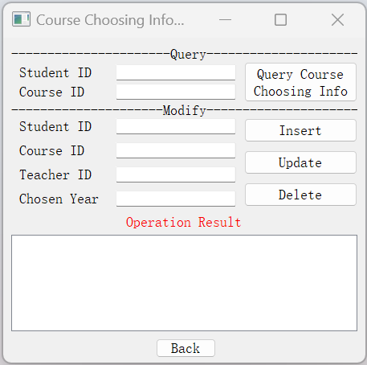

Figure 31

**2.2.3.1 Query Course Choosing Info**

If you press the “Query Course Choosing Info” button with empty Student ID and empty Course ID, information of all the course choosing will be shown, else if the Student ID or Course ID or both are not empty, the program will check if Course ID is a 7 digit decimal number and Student ID is a 10 digit decimal number, if not, an error prompt will be shown, if yes, the program will query for the information of this course. If there is no matched course, a prompt will be shown. This is very similar to **2.2.1.1 Query Student Info**, so here will not show figure here.

**2.2.3.1 Insert**

Insert a course choosing must input all the attributes correctly, the Student ID must be a 10 digit decimal number and exist in **Table Students**, the Course ID must be a 7 digit decimal number and exist in **Table Courses** , the Teacher ID must be a 5 digit decimal number and exist in **Table Teachers**, Chosen Year must be an integer number and smaller than the Canceled Year of the course and the grade of this student when he/she chosen the course must be larger than or equal to the grade demand of this course. If any attribute is invalid, there will be some prompts to tell the user. If all the attributes are valid, a prompt will be shown to tell the user that the Insert is Successful. This is very similar to **2.2.1.2 Insert**, so here will not show figure here.

**2.2.3.1 Update**

To update a course choosing information, user must input Student ID, Course ID and Teacher ID correctly. If there is no matched course choosing record, a prompt will be shown to tell the user. The other attributes can be empty or nonempty. If is empty, then this attribute will not be update, else this attribute will be update if the new one is valid. If all the input is correct, then a prompt will be shown to tell the user that the update is successful. If user want to modify the Teacher ID, user should firstly delete the course choosing record, then insert the new record. This is very similar to **2.2.1.3 Update**, so here will not show figure here.

**2.2.3.1 Delete**

To delete a course choosing information, user must input Student ID, Course ID and Teacher ID correctly. If there is no matched course choosing record, a prompt will be shown to tell the user. If the Student ID, Course ID and Teacher ID are all correct, then a prompt will tell the user that the delete is successful. This is very similar to **2.2.1.4 Delete**, so here will not show figure here.

**2.3 Change Password**

After clicking “Change Password” button, jump to the window for modifying password. Please refer to **6 Change Password** for detailed information.

**2.4 Initialize Database**

After clicking “Initialize Database” button, a prompt box will be opened as Figure 31.

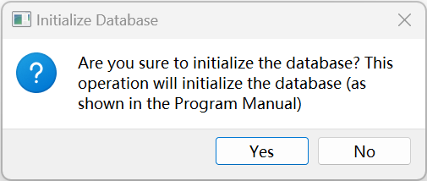

Figure 31

If user clicks “Yes”, the database will be initialize to the state shown in **Appendix 7**, and return to user menu.

If user clicks “No”, nothing will happen and return to user menu.

# 3 Menu-Teacher

Take user ID=00001 as sample account to login. The menu is shown in Figure 32.

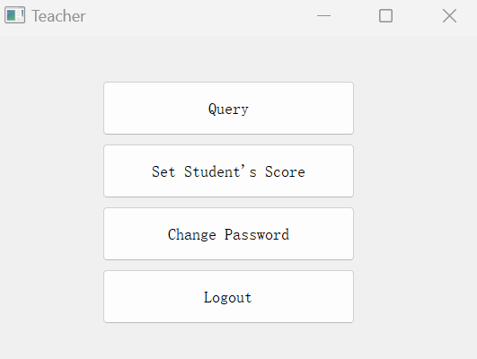

Figure 32

**3.1 Query**

After clicking “Query” button, jump to the window for different query demand. Please refer to **5 Query** for detailed introduction.

**3.2 Set Student’s Score**

After clicking “Set Student’s Score” button, jump to the window for setting student’s course score as Figure 33.

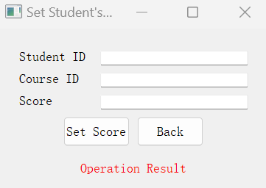

Figure 33

User must correctly input Student ID and Course ID, and Score must be a real number. If there is a student who choose the same course taught by the same teacher with different chosen year, the teacher can only set the score of the course choosing record with the recent chosen year. If there is more than one teacher who teach the same course at the same year with the same students, when one of the teachers sets the score of a student, the records in **Table CourseChoosing** of this student and this course with the same chosen year will all set the same score. User must teach this student in this course, else a prompt will tell user that user does not have the permission to set the student’s score in this course.

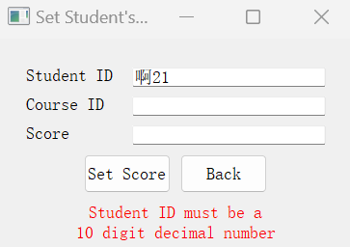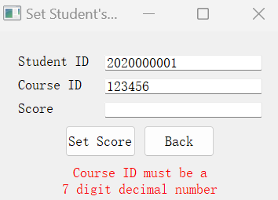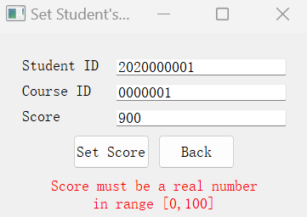

Figure 34 Figure 35 Figure 36

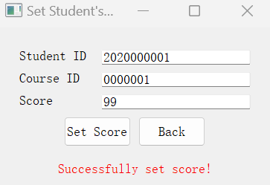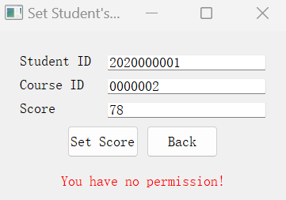

Figure 37 Figure 38

**3.3 Change Password**

After clicking “Change Password” button, jump to the window for modifying password. Please refer to **6 Change Password** for detailed information.

# 4 Menu-Student

Take user ID=2020000001 as sample account to login. The menu is shown in Figure 39.

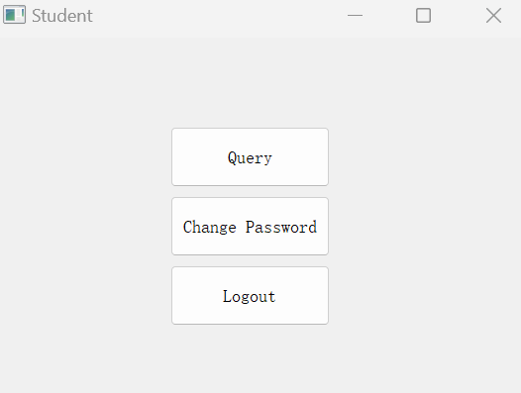

Figure 39

**4.1 Query**

After clicking “Query” button, jump to the window for different query demand. Please refer to **5 Query** for detailed introduction.

**4.2 Change Password**

After clicking “Change Password” button, jump to the window for modifying password. Please refer to **6 Change Password** for detailed information.

# 5 Query

Clicking “Query” button will show the window for different queries as shown in Figure 40.

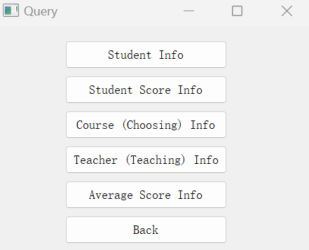

Figure 40

**5.1 Student Info**

The UI of this section is shown as Figure 41.

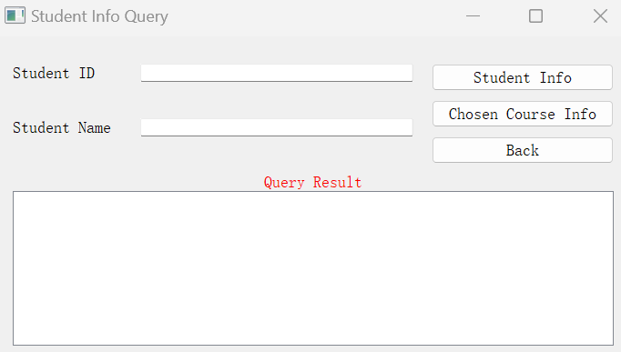

Figure 41

**5.1.1 Student Info**

After pressing “Student Info” button, students’ information will be shown as Figure 42. The Student ID and Student Name can be empty or nonempty. If Student ID is nonempty, then it should be a 10 digit decimal number, else a prompt will tell the user. If Student Name is nonempty, Student Name should not contain specific punctuation. If both Student ID and Student Name are empty, all the students’ information will be shown.

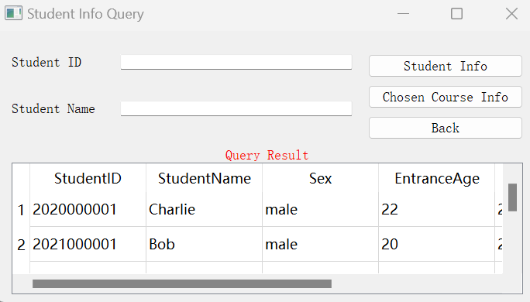

Figure 42

**5.1.2 Chosen Course Info**

After pressing “Chosen Course Info” button, the information of courses which is chosen by the student will be shown as Figure 43. The Student ID and Student Name can be empty or nonempty. If Student ID is nonempty, then it should be a 10 digit decimal number, else a prompt will tell the user. If Student Name is nonempty, Student Name should not contain specific punctuation. If both Student ID and Student Name are empty, all the chosen courses’ information will be shown.

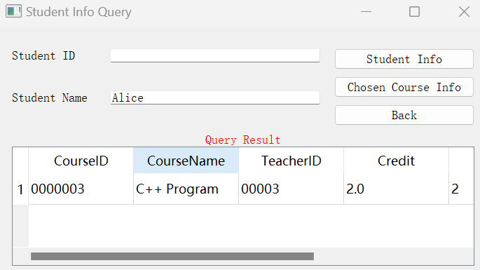

Figure 43

**5.2 Student Score Info**

The UI of this section is shown as Figure 44.

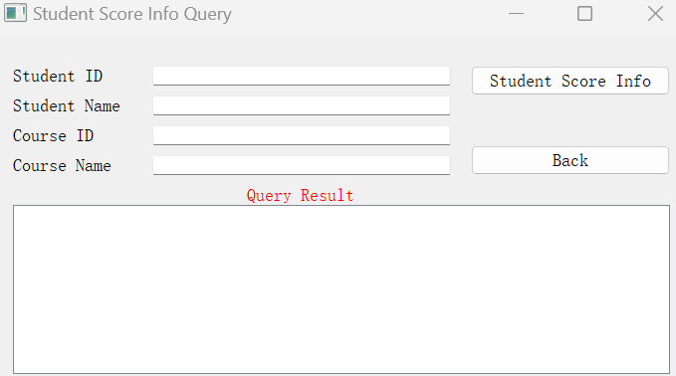

Figure 44

**5.2.1 Student Score Info**

After pressing “Student Score Info” button, the information of students’ score will be shown as Figure 45. The Student ID, Student Name, Course ID, Course Name can be empty or nonempty. If Student ID is nonempty, then it should be a 10 digit decimal number, else a prompt will tell the user. If Student Name is nonempty, Student Name should not contain specific punctuation. If Course ID is nonempty, then it should be a 7 digit decimal number, else a prompt will tell the user. If Course Name is nonempty, Course Name should not contain specific punctuation. If all the attributes are empty, all the score of student in every chosen course will be shown.

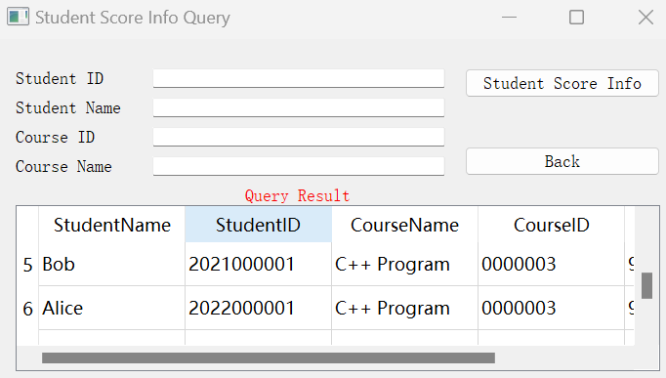

Figure 45

**5.3 Course (Choosing) Info**

The UI of this section is shown as Figure 46.

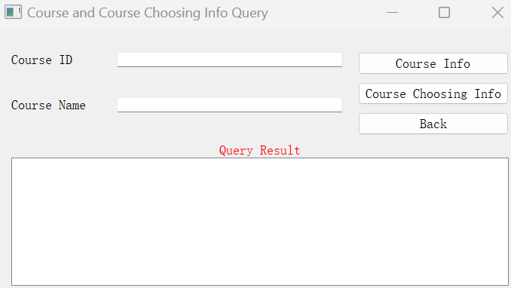

Figure 46

**5.3.1 Course Info**

After pressing “Course Info” button, the information of course will be shown as Figure 47. The Course ID and Course Name can be empty or nonempty. If Course ID is nonempty, then it should be a 7 digit decimal number, else a prompt will tell the user. If Course Name is nonempty, Course Name should not contain specific punctuation. If all the attributes are empty, information of all the courses will be shown.

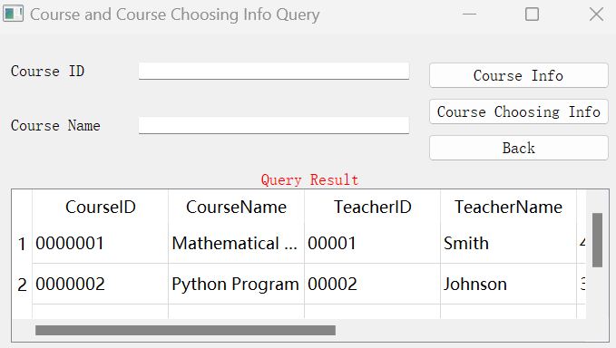

Figure 47

**5.3.2 Course Choosing Info**

After pressing “Course Choosing Info” button, the information of course choosing will be shown as Figure 48. The Course ID and Course Name can be empty or nonempty. If Course ID is nonempty, then it should be a 7 digit decimal number, else a prompt will tell the user. If Course Name is nonempty, Course Name should not contain specific punctuation. If all the attributes are empty, information of all the course choosing will be shown.

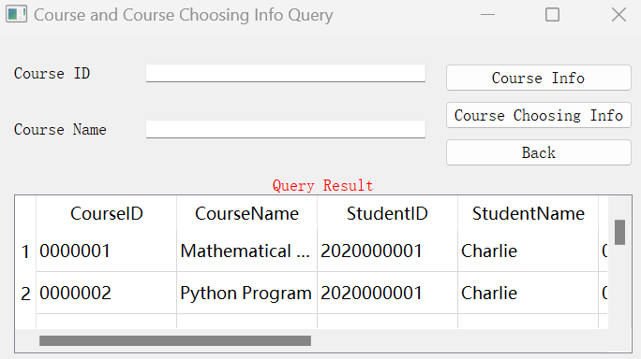

Figure 48

**5.4 Teacher (Teaching) Info**

The UI of this section is shown as Figure 49.

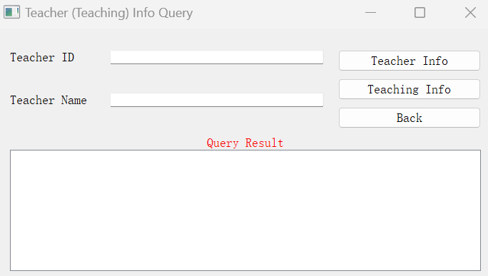

Figure 49

**5.4.1 Teacher Info**

After pressing “Teacher Info” button, the information of teacher will be shown as Figure 50. The Teacher ID and Teacher Name can be empty or nonempty. If Teacher ID is nonempty, then it should be a 5 digit decimal number, else a prompt will tell the user. If Teacher Name is nonempty, Teacher Name should not contain specific punctuation. If all the attributes are empty, information of all the teachers will be shown.

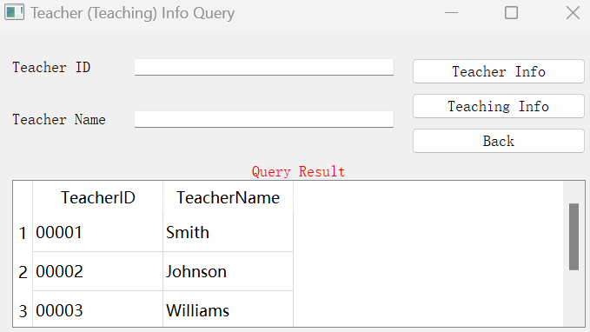

Figure 50

**5.4.2 Teaching Info**

After pressing “Teaching Info” button, the information of the courses taught by the teacher will be shown as Figure 51. The Teacher ID and Teacher Name can be empty or nonempty. If Teacher ID is nonempty, then it should be a 5 digit decimal number, else a prompt will tell the user. If Teacher Name is nonempty, Teacher Name should not contain specific punctuation. If all the attributes are empty, information of all the courses taught by teachers will be shown.

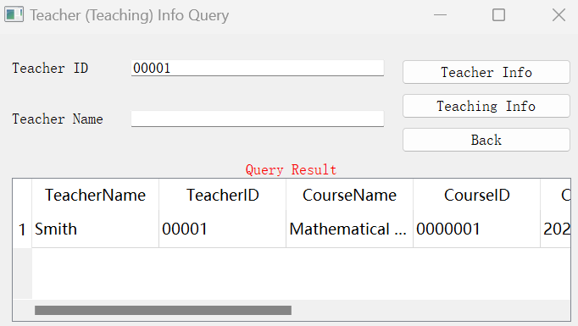

Figure 51

**5.5 Average Score Info**

The UI of this section is shown as Figure 52.

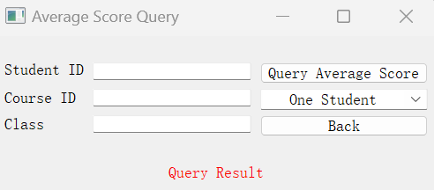

Figure 52

**5.51 Query Average Score**

After pressing “Query Average Score” button, the average score with different conditions will be shown.

If the chosen condition is “One Student”, the Student ID must be a 10 digit decimal number, and the program will show the average score of all the course chosen by this student as Figure 53.

If the chosen condition is “All Student”, then the program will show the average score of all the course chosen by every student as Figure 54.

If the chosen condition is “Course”, the Course ID must be a 7 digit decimal number, while the Class can be empty or not. If the Class is empty, the program will show the average of students choosing this course as Figure 55. If the Class is not empty, the program will show the average of students who are in this class and have chosen this course.

If the chosen condition is “Class”, Class must have an correct input, while the Course ID can be empty or not. If the Course ID is empty, the program will show the average of students in this Class. If the Course ID is not empty, the program will show the average of all courses of students who are in this class and have chosen this course as Figure 56.

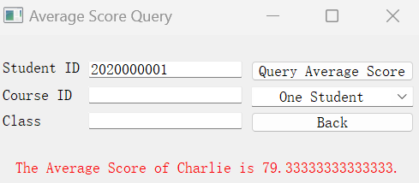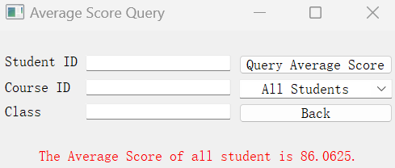

Figure 53 Figure 54

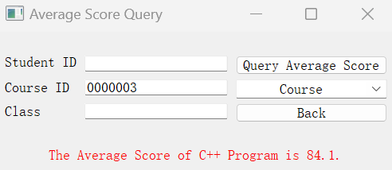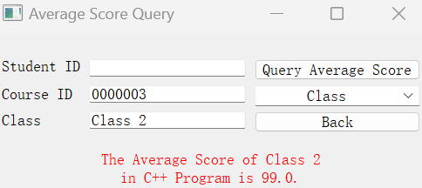

Figure 55 Figure 56

# 6 Change Password

Clicking “Change Password” button will show the window for modifying password as Figure 57.

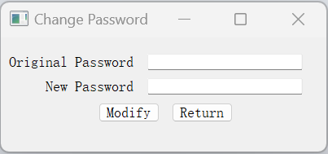

Figure 57

If user wants to give up modifying, please click “Return” button and return to the user menu.

If user decides to modify password, please enter the old password correctly in the first text blank; enter new password in the second text blank; click “Modify” button to submit. Error will be displayed if the old password is incorrect as Figure 58. Attention, both Original Password and New Password should not contain specific punctuation, or error will be displayed as Figure 59 and Figure 60.

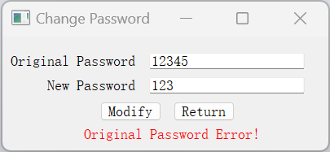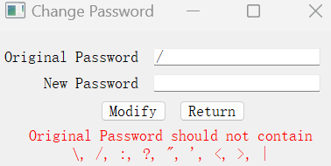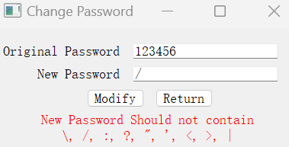

Figure 58 Figure 59 Figure 60

If the password modification is successful, “Successfully Modify!” will be displayed as Figure 61.

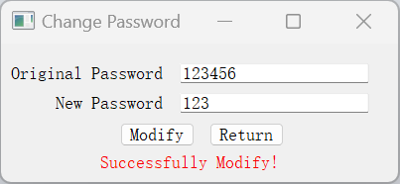

Figure 61

# 7 Appendix: Original Data in Database

**7.1 “Students” Table**

|  |  |  |  |  |  |
| --- | --- | --- | --- | --- | --- |
| StudentID | StudentName | Sex | EntranceAge | EntranceYear | Class |
| 2022000001 | Alice | female | 18 | 2022 | Class 1 |
| 2022000002 | Jack | male | 19 | 2022 | Class 1 |
| 2022000003 | Rose | female | 18 | 2022 | Class 1 |
| 2021000001 | Bob | male | 20 | 2021 | Class 2 |
| 2020000001 | Charlie | male | 22 | 2020 | Class 3 |

**7.2 “Teachers” Table**

|  |  |
| --- | --- |
| TeacherID | TeacherName |
| 00001 | Smith |
| 00002 | Johnson |
| 00003 | Williams |

**7.3 “Courses” Table**

|  |  |  |  |  |  |
| --- | --- | --- | --- | --- | --- |
| CourseID | CourseName | TeacherID | Credit | Grade | CanceledYear |
| 0000001 | Mathematical analysis | 00001 | 4 | 1 | None |
| 0000002 | Python Program | 00002 | 3 | 1 | None |
| 0000003 | C++ Program | 00003 | 2 | 2 | 2023 |

**7.4 “CourseChoosing” Table**

|  |  |  |  |  |
| --- | --- | --- | --- | --- |
| StudentID | CourseID | TeacherID | ChosenYear | Score |
| 2020000001 | 0000001 | 00001 | 2022 | 78.0 |
| 2020000001 | 0000002 | 00002 | 2021 | 100.0 |
| 2020000001 | 0000003 | 00003 | 2020 | 60.0 |
| 2021000001 | 0000002 | 00002 | 2022 | 90.0 |
| 2021000001 | 0000003 | 00003 | 2021 | 99.0 |
| 2022000001 | 0000003 | 00003 | 2022 | 95.0 |
| 2022000002 | 0000003 | 00003 | 2022 | 88.5 |
| 2022000003 | 0000003 | 00003 | 2022 | 78.0 |

**7.5 “AccountPassword” Table**

|  |  |  |
| --- | --- | --- |
| Account | Occupation | Password |
| 00000 | admin | 123456 |
| 00001 | teacher |
| 00002 |
| 00003 |
| 2020000001 | student |
| 2021000001 |
| 2022000001 |
| 2022000002 |
| 2022000003 |